**Gain Margin and Phase Margin**

Gain margin and phase margin are two parameters to assess the performance of a circuit. Depending on the values of both, we judge factors such as the stability of the circuit etc.

**Gain Margin:** The value of the gain at the same frequency where the phase crosses -180° is called as the gain margin of the circuit. The frequency at which the phase crosses -180° is called phase crossover frequency. Hence, the value of the gain at the phase crossover frequency is called as the gain margin.

**Phase Margin:** The value of the phase relative to -180°, at the same frequency at which the gain crosses 0dB (gain crossover frequency) is called as the phase margin.

The following figure shows the gain margin and the phase margin for a particular circuit.

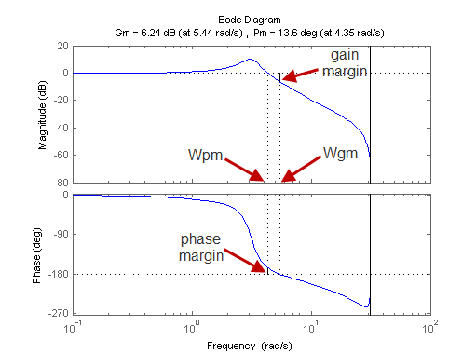

Usually, for any circuit, the gain crossover frequency is less than the phase crossover frequency.

Both these parameters can be calculated in LT-SPICE also. The following figure shows a sample graph from a cascade amplifier simulation done in class.

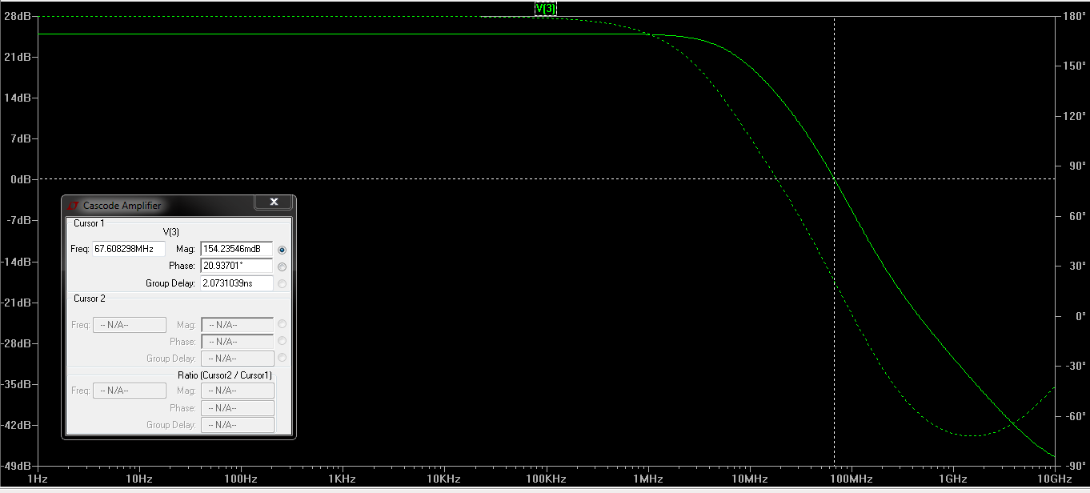

The cursor can be obtained by left clicking the ‘V(3)’ written at the heading of the graph. The cursor is shifted till the magnitude field in the box shows 0 dB (or a value closest). The phase margin s calculated at this value. The value of the phase is measured and the phase relative to -180° is calculated.

e.g. In this case, the phase margin is 20.93 - (-180) = 200.93°.

Similarly, the value of the gain margin can be calculated by moving the cursor to a point where value of phase is -180°.